LABORATORIYA ISHI 15

Mavzu: JSON formatda ma’lumotlarni olish va ulash

1. Ishning maqsadi
Ushbu laboratoriya ishining maqsadi — Avia Kassa loyihasida JSON formatidagi ma’lumotlar bilan ishlashni o‘rganish. Talaba:
- JSON tushunchasini va sintaksisini tushunadi;
- JavaScript yordamida JSON ma’lumotlarini olish va o‘qishni o‘rganadi;
- Olingan ma’lumotlarni web-sahifada interaktiv tarzda chiqarish ko‘nikmalarini shakllantiradi.

2. Nazariy qism

2.1 JSON nima?
JSON (JavaScript Object Notation) — bu ma’lumotlarni saqlash va almashish uchun ishlatiladigan yengil format.
- O‘qilishi oson va strukturali;
- Server va brauzer o‘rtasida ma’lumot uzatishda ishlatiladi;
- API va REST servislar bilan ishlashda keng qo‘llaniladi.

2.2 JSON va JavaScript
- JSON sintaksisi JavaScript obyektlariga o‘xshaydi;
- Kalitlar har doim qo‘shtirnoq ichida bo‘ladi;
- Faqat ma’lumotlar saqlanadi, funksiyalar yo‘q.

2.3 JSON bilan ishlash usullari
- JSON.parse() — JSON matnini JavaScript obyektiga aylantiradi;
- JSON.stringify() — JavaScript obyektini JSON formatiga aylantiradi;
- fetch() — server yoki .json fayldan ma’lumot olish uchun ishlatiladi.

3. Amaliy qism: Avia Kassa misoli
<!DOCTYPE html>
<html lang="uz">
<head>
<meta charset="UTF-8">
<title>Avia Kassa – Interaktiv Loyiha</title>
<style>
body{
font-family:Arial, sans-serif;
background:#f0f3fa;
padding:20px;
}
h2{
text-align:center;
color:#1a237e;
}
input, select, button{
padding:8px;
margin:5px 0;
border-radius:6px;
border:1px solid #aaa;
}
table{
width:100%;
border-collapse:collapse;
background:white;
box-shadow:0 4px 12px rgba(0,0,0,.2);
margin-top:10px;
}
th, td{
padding:10px;
border:1px solid #ddd;
text-align:center;
}
th{
background:#303f9f;
color:white;
}
tr:nth-child(even){
background:#f5f6ff;
}
tr:hover{
background:#e8eaf6;
}
#cart{
margin-top:20px;
background:#fff;
padding:15px;
border-radius:8px;
box-shadow:0 4px 10px rgba(0,0,0,.2);
}
</style>
</head>
<body>
<h2>✈️ Avia Kassa</h2>
<h3>Qidiruv:</h3>
<input id="searchInput" type="text" placeholder="Shahar yoki reys raqami...">
<table>
<thead>
<tr>
<th>№</th>
<th>Reys</th>
<th>Manzil</th>
<th>Chiptalar soni</th>
<th>Narx (UZS)</th>
<th>🛒 Savatga qo‘shish</th>
</tr>
</thead>
<tbody id="flightTable"></tbody>
</table>
<div id="cart">
<h3>🛒 Savat</h3>
<ul id="cartList"></ul>
</div>

<h3>📦 Buyurtma berish</h3>
<form id="orderForm">
<input type="text" id="name" placeholder="Ismingiz" required>
<input type="tel" id="phone" placeholder="Telefon raqamingiz" required pattern="\\+998\\s\\d{2}\\s\\d{7}">
<button type="submit">Buyurtma yuborish</button>
</form>
<script>
// JSON ma’lumotlar
let flightsJSON = `[
{"id":1,"flight":"HY-101","destination":"Toshkent → Moskva","tickets":50,"price":1200000},
{"id":2,"flight":"HY-102","destination":"Toshkent → Istanbul","tickets":30,"price":1500000},
{"id":3,"flight":"HY-103","destination":"Toshkent → Dubay","tickets":20,"price":1800000},
{"id":4,"flight":"HY-104","destination":"Toshkent → Ankara","tickets":25,"price":1400000},
{"id":5,"flight":"HY-105","destination":"Toshkent → Seul","tickets":15,"price":2000000}
]`;
let flights = JSON.parse(flightsJSON);
let cartList = document.getElementById("cartList");
// Jadvalni chiqarish
function displayFlights(data){
let table = document.getElementById("flightTable");
table.innerHTML = "";
data.forEach(flight => {
let row = document.createElement("tr");
row.innerHTML = `
<td>${flight.id}</td>
<td>${flight.flight}</td>
<td>${flight.destination}</td>
<td>${flight.tickets}</td>
<td>${flight.price.toLocaleString()}</td>
<td><button class="addBtn">➕</button></td>
`;
// CLICK event – savatga qo‘shish
row.querySelector(".addBtn").addEventListener("click", ()=>{
let li = document.createElement("li");
li.textContent = `${flight.flight} – ${flight.destination} – ${flight.price.toLocaleString()} UZS`;
cartList.appendChild(li);
});
table.appendChild(row);
});
}
// Boshlang‘ich jadval
displayFlights(flights);
// Qidiruv funksiyasi (change/keyUp)
document.getElementById("searchInput").addEventListener("keyup", function(){
let value = this.value.toLowerCase();
let filtered = flights.filter(f =>
f.destination.toLowerCase().includes(value) ||
f.flight.toLowerCase().includes(value)
);
displayFlights(filtered);
});
// SUBMIT event – forma validation
document.getElementById("orderForm").addEventListener("submit", function(e){
e.preventDefault();
let name = document.getElementById("name").value.trim();
let phone = document.getElementById("phone").value.trim();
let phonePattern = /^\+998\s\d{2}\s\d{7}$/;
if(name === "" || phone === ""){
alert("Iltimos, barcha maydonlarni to‘ldiring!");
return;
}
if(!phonePattern.test(phone)){
alert("Telefon raqam formatiga e’tibor bering: +998 xx xxxxxxx");
return;
}
if(cartList.children.length === 0){
alert("Iltimos, kamida bitta reys tanlang!");
return;
}
alert(`Buyurtmangiz qabul qilindi, ${name}!`);
cartList.innerHTML = "";
document.getElementById("orderForm").reset();
});
</script>
</body>
</html>
Natija:
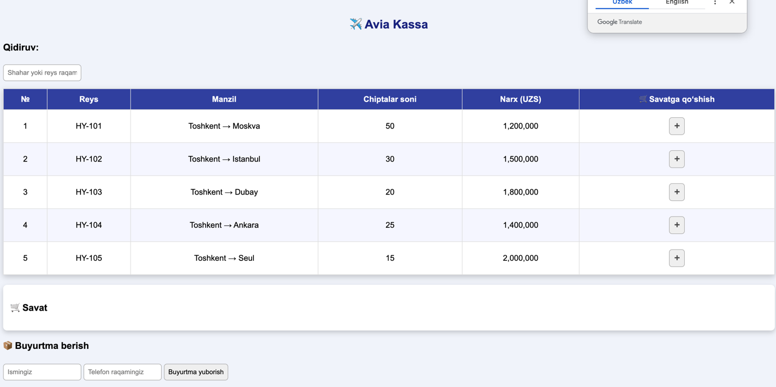

Xulosa
- Loyihada JSON ma’lumotlarni olish va DOM orqali chiqarish amaliyoti bajarildi.
- JavaScript eventlari (click, keyup, submit) orqali interaktivlik ta’minlandi.
- Forma validation yordamida foydalanuvchi xatolari kamaytirildi.
- Natijada foydalanuvchi qulay, dinamik va xavfsiz Avia Kassa sahifasi yaratildi.

